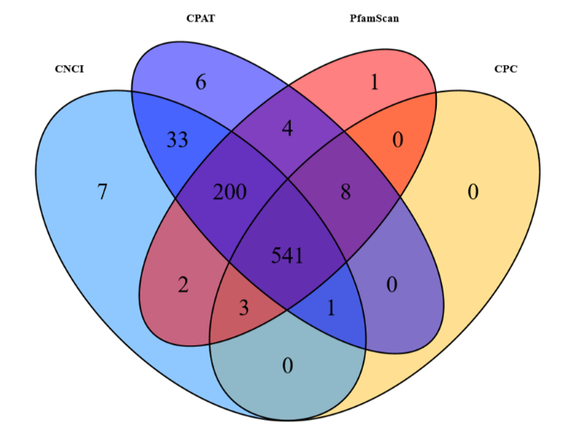
Supplemental file 3. Venn Diagram of screening novel lncRNA using four coding potential rediction software. Blue represents CNCI software, purple represents CPAT software, red represents PfamScan software, and yellow represents CPC software.

